## Justification for the project

## Market Research

Higher education industry has been one of the fastest growing industries, especially in countries like United States of America, United Kingdom, Europe and the Australia. Number of International students have is growing exponentially, nearly 4.3 million students are enrolled in university-level education outside their home country. Australia, UK, Switzerland, New Zealand and Austria have in descending order, the highest percentage in international students. (OECD)

Asian students represent 53% of foreign student enrolled worldwide. The largest numbers of foreign students are from China, India, Korea. OECD countries receive more international students than they send abroad for tertiary education. Almost three times as many foreign students are enrolled in tertiary education in OECD countries as there are OECD citizens studying abroad. (OECD)

83% of foreign students are enrolled in G20 countries while 77% are enrolled in OECD countries. These proportions have remained stable during the past decade. The number of international students in Oceania has tripled since 2000, although this region only accounts for 10% of the global average students. Australia, United Kingdom, Canada, France and the United States together receive more than 50% of all foreign students worldwide. Over the past three decades, the number of students enrolled outside their country of citizenship has risen dramatically, from 0.8 million worldwide in 1975 to 4.3 million in 2011, a more than fivefold increase.

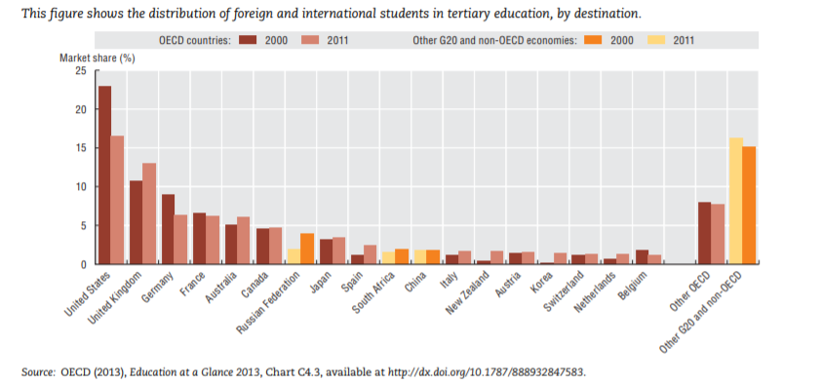

This chart shows that there has been an increase in the overseas student market share in Australian Higher Education sector. While a decrease is observed in United States, Germany, France. This statistic only proves growing percent of students highly look up to Australia as their next study destination or preferred higher education destination. The reason for prospective students favouring Australia can be justified by affordable tuition fees, ability to easily secure a place on desired course or university, Location (most universities are located in developed cities or touristy destination), option to stay back after completing education to find work (Post-Study work visa or Permanent residency option). Major reason for why there has been decline in international student in United States can be related to increasing tuition fees, competition to secure a place on the desired course and university, less university options for favourable location, difficulty to get a post study work visa or permanent residency.

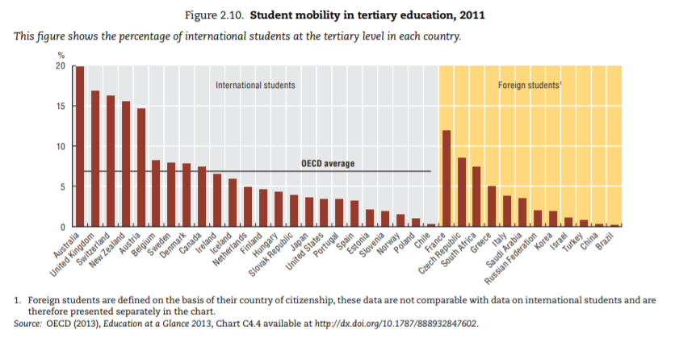

The above chart shows that Australia has the highest percentage of international than any other OECD countries. 20% of total students enrolled in Australian education program, come from outside of Australia or don’t hold citizenship at the time of enrolment. This trend is only assumed to increase as the economy is bound to grow.

There is a high demand for sound ICT solution which will streamline and speed up the delivery of new and constantly changing information right to the prospective international students. Universities would like to market their programs, campus, features and facilities at the highest priority, while the students would like to stay updated with their new study adventure on all widely used platforms. The traditional way students find university information is to head the university website, search for available courses, tuitions fees, and the process for enrolment, which can be very tedious, repetitive and time-consuming task which needs to be done with each university separately. Currently, there is no platform that will provide course information, handle application and provide a portal for universities easily process student applications, all in place, on one platform, until Kiran Das gave life to his amazing idea of CoursePal.

## CoursePal

CoursePal is new business venture which is in its initial phase of development. The CoursePal website was developed by BRIKS Infotech, which is an upcoming start-up, founded and owned by Kiran Das, a JCUB alumni. CoursePal provides information on university, course, location, part-time job, living options, Visa, on-arrival and other related information, necessary for the students. It is the one place students will find authentic and updated information which they can rely on 100%.

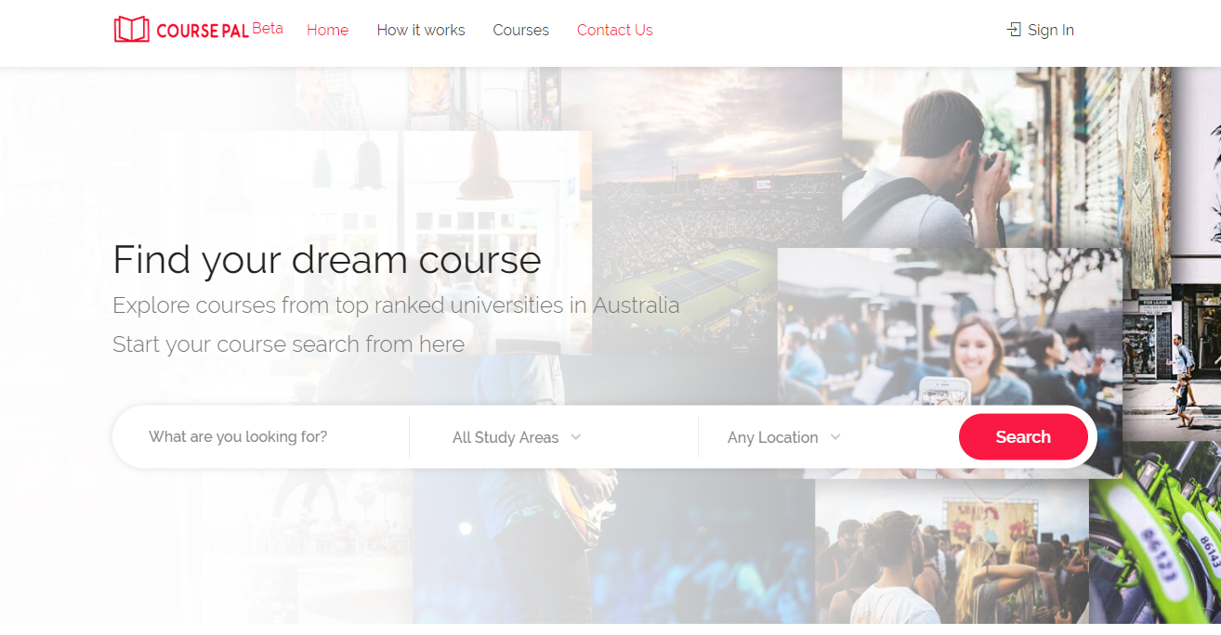

CoursePal also provides students application handling capabilities which will be viewed by respective universities using a university log-in portal provided by CoursePal. Universities then can download all the documents the student has uploaded and process the application, providing a faster, concise system to handle enrolment applications without the need for worrying the underlying implementation. In addition, CoursePal has a very user-friendly appeal which attracts majority of the young student age group. Currently, CoursePal website is still in Beta development phase and we are undertaking the development for android application for the same.

## Project Goals

The project is designed to be developed, tested and delivered between March and September 2019, as part of ICT 1 and ICT 2, course subjects under James Cook University. The main project is to develop the android application to extend usability for current CoursePal web platform. We aim to develop a completely new android app for users in android OS segment, which is in line with CoursePal brand thus eliminating the need to use a browser or a computer to access coursepal.com.au. We plan to develop the same look and feel, which will ensure 100% user acceptance.

Our secondary goal is to learn the technologies involved in development by working on them. Learning through the means of this project will prove very beneficial for us as developers. We also aim to learn team work, effective communication between team members and the client, software development life cycle-requirements gathering to project deployment and the whole cycle, implementing agile methodology.

## Milestones

The project development cycle is based on completing various milestones. Milestones are used to record the group progress and developing highest priority functionalities first. The following milestones explain the overall project cycle.

**Milestone 1**

**The project requirements collection and drafting Client agreement are initial steps and forms milestone 1. This was completed during the client meeting and the agreement contract was signed. User stories were noted, and this marks the completion of milestone 1 as of 27th April 2019.**

**Milestone 2**

**The project planning and environment setup marks milestone 2. We have decided to use the JetBrains IntelliJ IDE for App developing as it has build functionalities, emulator, easy and reliable to use. Kotlin as our development language. Kotlin is considered to be the most versatile native development language. We are using github which is based on git version control as a collaboration platform, Trello to effectively communicate between client, group members and to assign tasks.**

**Milestone 3**

**Iteration Planning and task assignment is achieved in 3rd milestone. Iterative development approach refers to the way of breaking down the software development into small chunks, and designed, developed and tested in repeated cycles. The first feature the client has requested to be developed is the search functionality. Other features will be implemented according to the client demand upon further meetings. Once the top priority features are developed, alpha release will be scheduled with the client. The timeline may vary for this milestone as things often tend to not work as planned, but a top priority will be given to ensure that tasks are completed on time and as planned by each team member, managing and balancing work loads. Our initial iteration will be 20 working days long, each day members will decide to meet and work on assigned tasks for at least 6 productive hours.**

**Milestone 4**

**Development and testing of all feature will be done in the last milestone. After the completion the beta release will be delivered to the client. Beta release will be deployed in Google AppStore and will be then tested on various scale.**